**NAME**: S SHELVASUJITH

**REG NO**: 192124191

|  |  |
| --- | --- |
| **Ex. No. 1.1** | **CONFIGURATION OF NETWORK DEVICES** |
| **Date:3-10-2023** |

### AIM:

To establish a configuration of Network Devices using Packet Tracer tools

### REQUIREMENTS:

1. End device - They are the devices through which we can pass message from one device to another and they are interconnected.
2. Switch/Hub - Interface Between two devices.
3. Cable - Used to connect two devices.

### PROCEDURE:

### STEP 1: Click on end devices, select generic Pc’s drag and drop it on the

### window. Click on SWITCH drag and drop it on the window.

### STEP 2: Select the straight through cable and connect all end device to switch. Assign the IP address for all end devices. (Double click the end device Select →

### desktop → IP configuration static)

### STEP 3: Now set the IP address to Host A (192.168.1.1) in static mode. Similarly set IP address for Host B (192.168.1.2) and Host C (192.168.1.3)

### STEP 5: To view the IP address, give ipconfig command in command prompt. Using ping command, we can establish communication between two host devices.

### STEP 6: Now display the packet transmission in simulation mode.

1. HUB

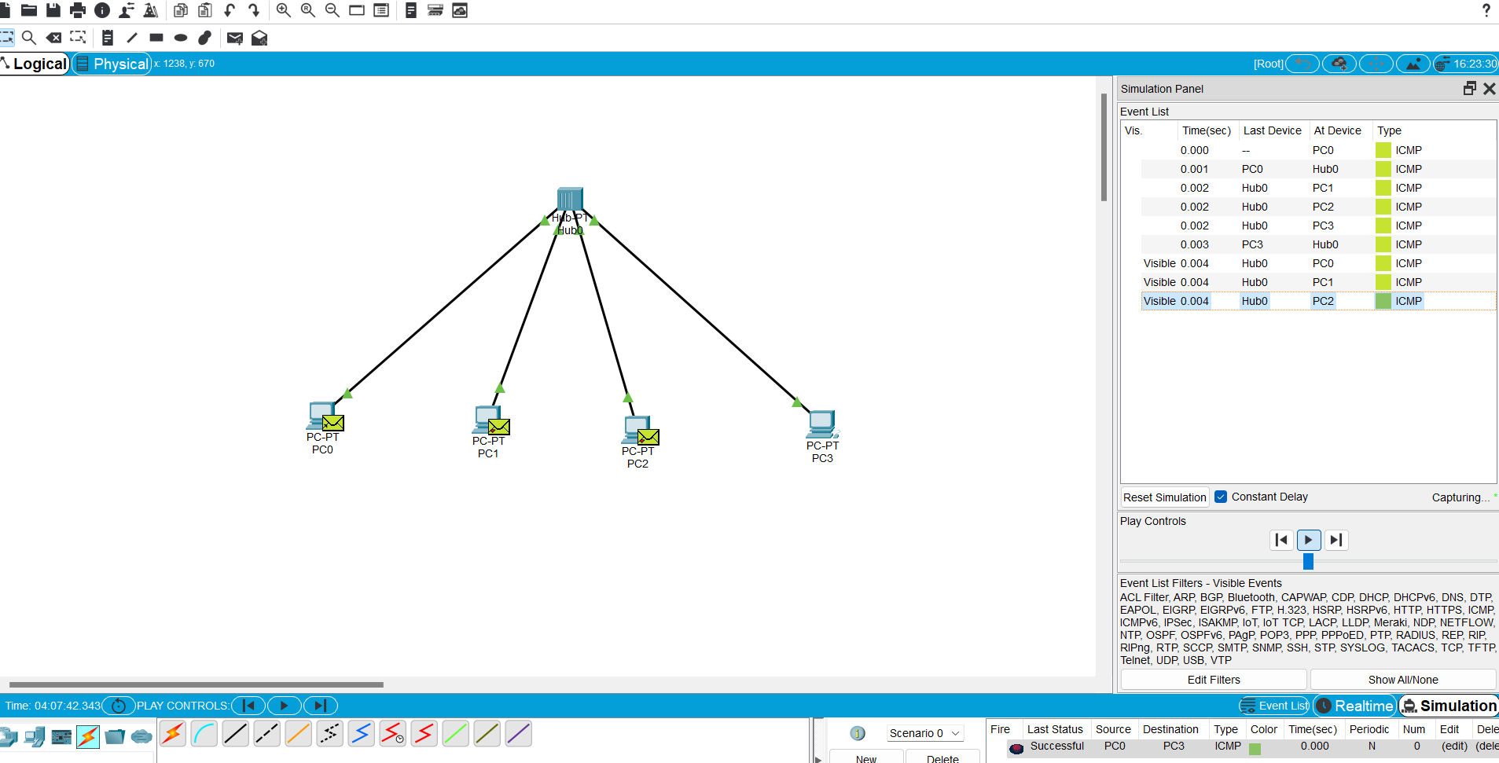

1. SWITCH

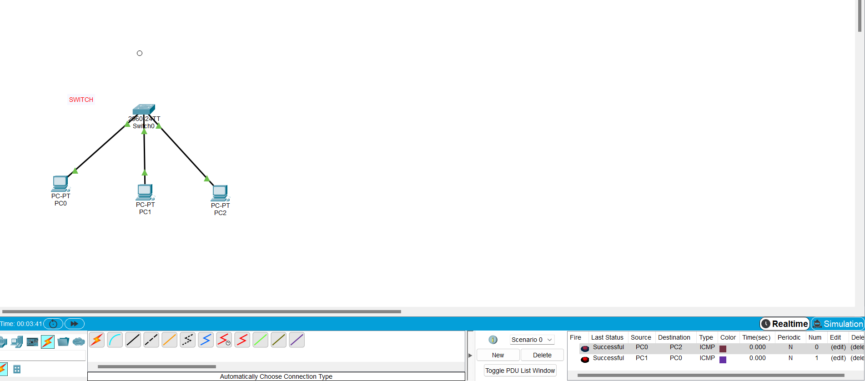

1. ETHERNET

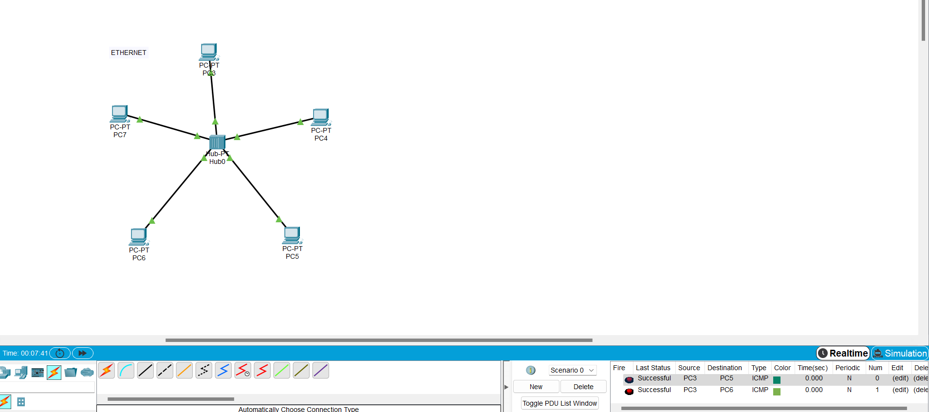

1. BROADCAST

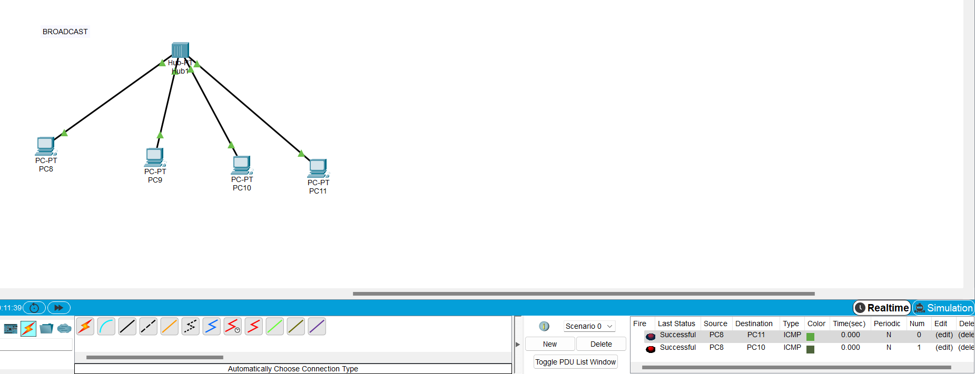

**RESULT:**

Configuration of network devices is verified successfully